**MongoDB assignment day 1**

**Query Insert Documents:**

db.Movies.insert([

{

title: "Fight Club" ,

writer : "Chuck Palahniuko" ,

year : 1999,

actors : ["Brad Pitt", "Edward Norton"]

},

{

title: "Pulp Fiction",

writer : "Quentin Tarantino",

year : 1994,

actors :["John Travolta" ,"Uma Thurman"]

},

{

title: "Inglorious Basterds",

writer : "Quentin Tarantino",

year : 2009,

actors :["Brad Pitt", "Diane Kruger" ,"Eli Roth"]

},

{

title: "The Hobbit: An Unexpected Journey",

writer: "J.R.R. Tolkein",

year : 2012,franchise : "The Hobbit"

},

{

title: "The Hobbit: The Desolation of Smaug",

writer: "J.R.R. Tolkein",

year : 2013,

franchise : "The Hobbit"},

{

title: "The Hobbit: The Battle of the Five Armies",

writer : "J.R.R. Tolkein",

year : 2012,

franchise : "The Hobbit",

synopsis : "Bilbo and Company are forced to engage in a war against an array of combatants and keep the Lonely Mountain from falling into the hands of a rising darkness."},

{

title : "Pee Wee Herman's Big Adventure"

},

{

title : "Avatar"

}

])

**Query / Find Documents:**

query the movies collection to

**1: Get all documents**

db.Movies.find()

**2: get all documents with writer set to "Quentin Tarantino".**

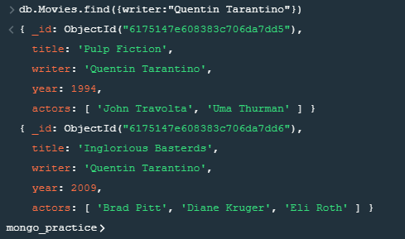

**3. get all documents where actors include "Brad Pitt".**

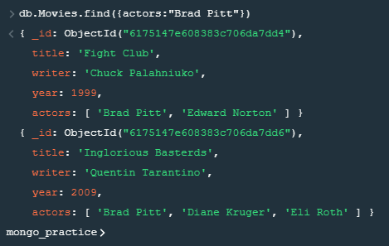

**4. get all documents with franchise set to "The Hobbit".**

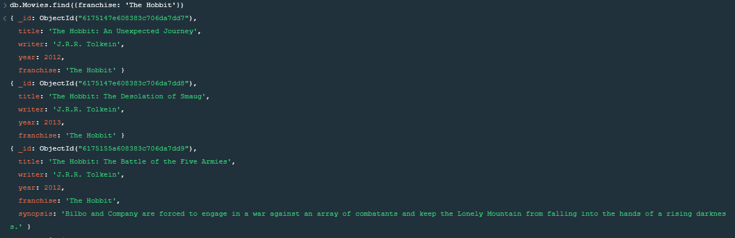

**5. get all movies released in the 90s.**

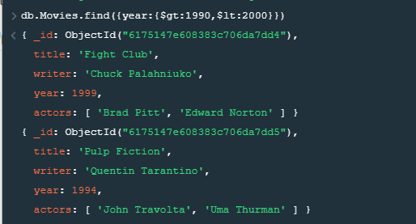

**6. get all movies released before the year 2000 or after 2010.**

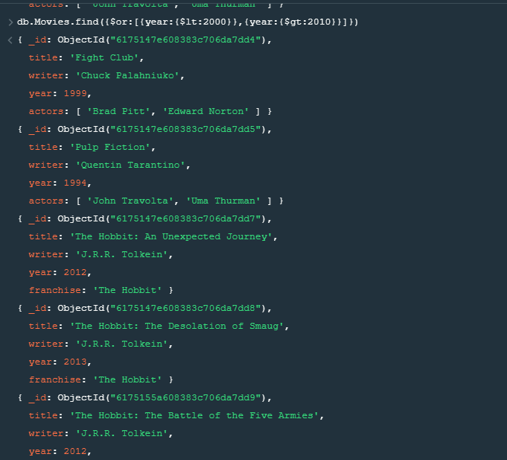

**Update Documents**

1. **add a synopsis to "The Hobbit: An Unexpected Journey": "A reluctant hobbit, Bilbo Baggins, sets out to the Lonely Mountain with a spirited group of dwarves to reclaim their mountain home - and the gold within it - from the dragon Smaug."**

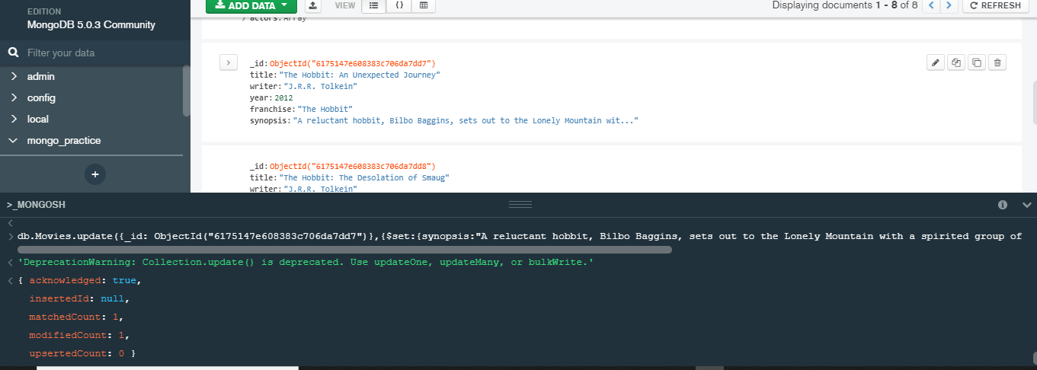

1. **add a synopsis to "The Hobbit: The Desolation of Smaug" : "The dwarves, along with Bilbo Baggins and Gandalf the Grey, continue their quest to reclaim Erebor, their homeland, from Smaug. Bilbo Baggins is in possession of a mysterious and magical ring."**

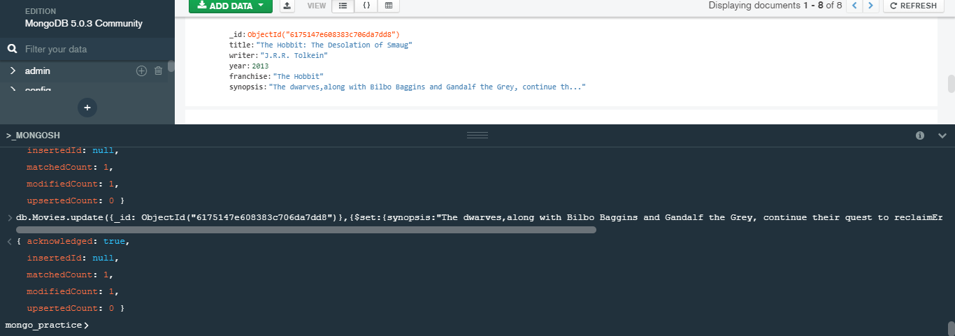

1. **add an actor named "Samuel L. Jackson" to the movie "Pulp Fiction".**

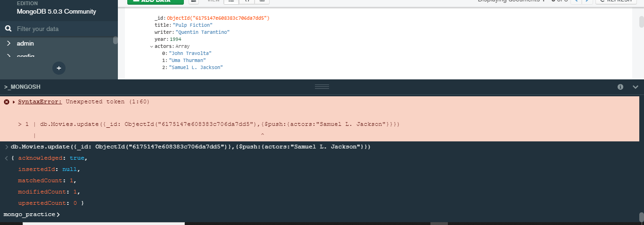

**TEXT Search**

1. **find all movies that have a synopsis that contains the word "Bilbo".**

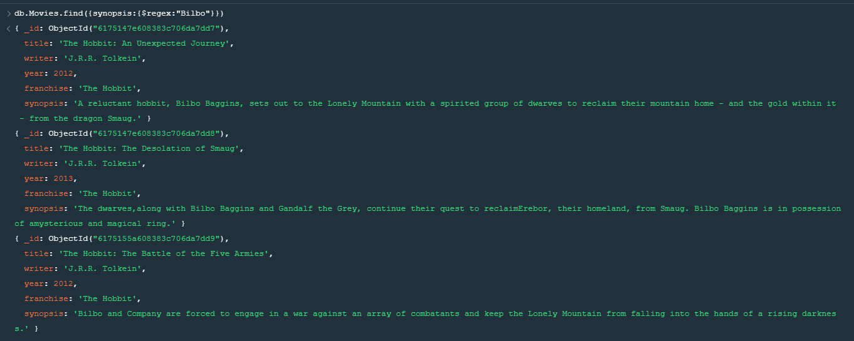

1. **find all movies that have a synopsis that contains the word "Gandalf".**

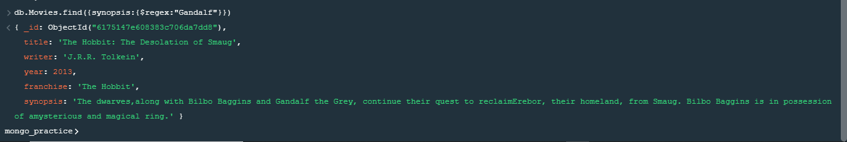

1. **find all movies that have a synopsis that contains the word "Bilbo" and not the word "Gandalf".**

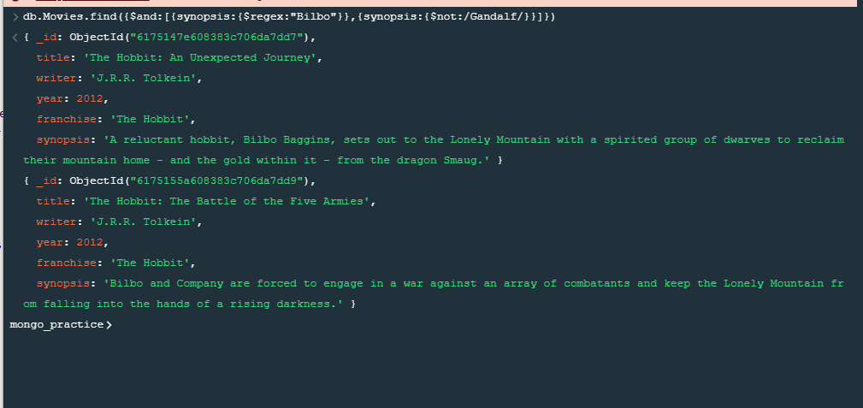

1. **find all movies that have a synopsis that contains the word "dwarves" or "hobbit".**

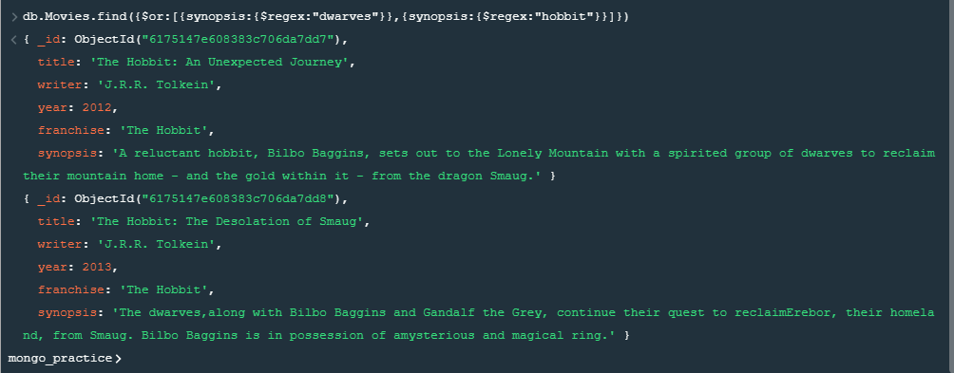

1. **find all movies that have a synopsis that contains the word "gold" and "dragon**".

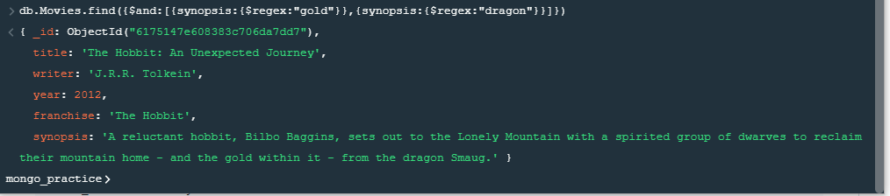

**DELETE Documents**

1. **delete the movie "Pee Wee Herman's Big Adventure".**

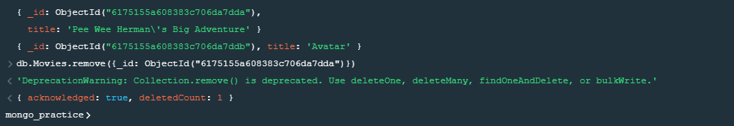

1. **delete the movie "Avatar".**



**Relationships**

1. **Insert the following documents into a users collection.**

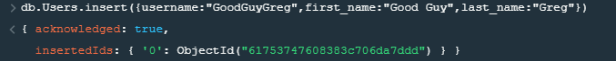

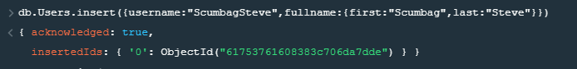

1. **Insert the following documents into a Posts collection.**



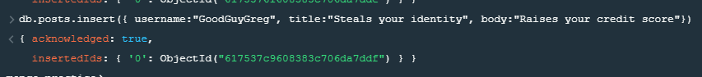

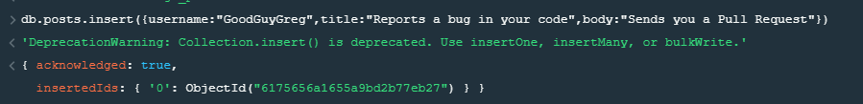

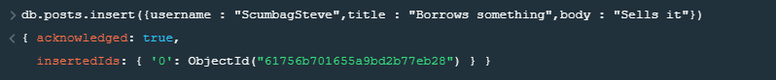





1. **Insert the following documents into a comments collection.**



where [post_obj_id] is the ObjectId of the posts document: "Borrows something".



where [post_obj_id] is the ObjectId of the posts document: "Borrows everything".



where [post_obj_id] is the ObjectId of the posts document: "Forks your repo on github”.



where [post_obj_id] is the ObjectId of the posts document: "Passes out at party".



where [post_obj_id] is the ObjectId of the posts document: "Reports a bug in your code".

**Querying related collections**

1. **find all users.**

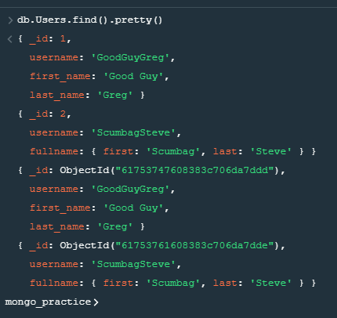

**2.find all posts.**

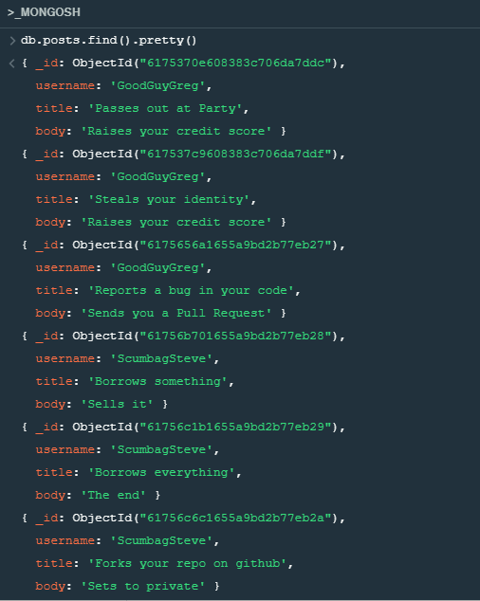

**3.find all posts that was authored by "GoodGuyGreg".**

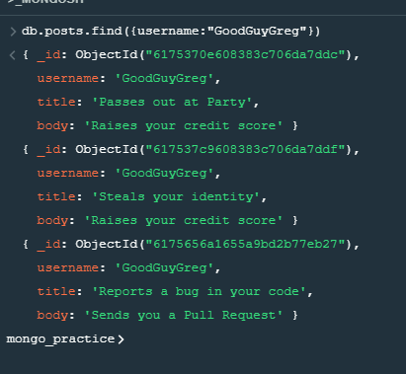

1. **find all posts that was authored by "ScumbagSteve".**

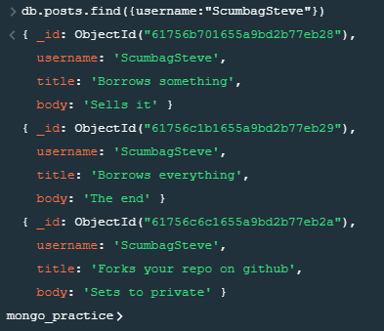

1. **find all comments.**

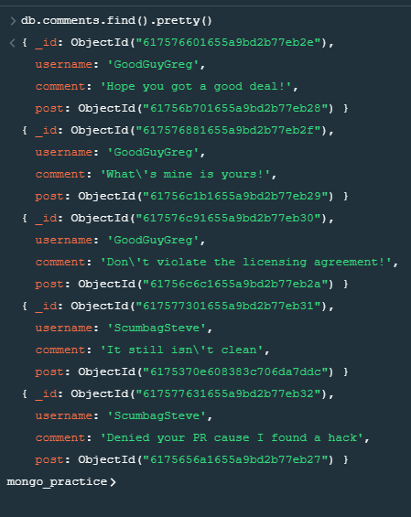

1. **find all comments that was authored by "GoodGuyGreg".**

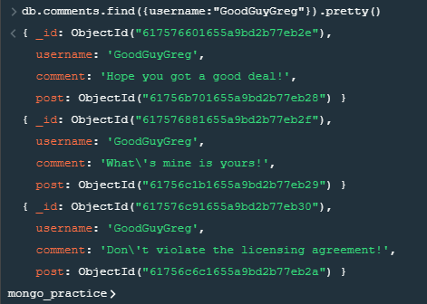

1. **find all comments that was authored by "ScumbagSteve".**

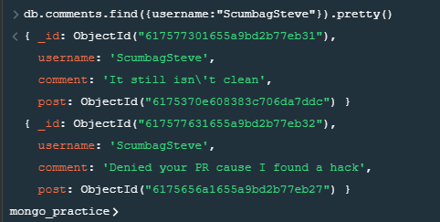

1. **find all comments belonging to the post "Reports a bug in your code".**